Joined Together
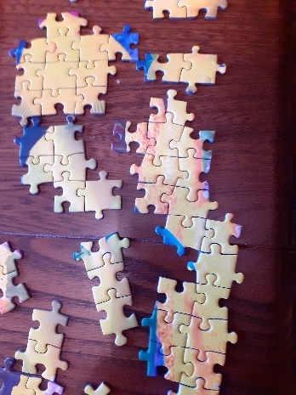
In the same way, we are many, but in Christ we are all one body. Each one is a part of that body. And each part belongs to all the other parts.
Romans 12:5

Our school community is like a jigsaw. Lots of small pieces make up the whole picture. When one piece is missing you notice straight away, the picture is not complete. When one person is missing the whole class or school notices.
Take a puzzle piece.
Look at the ‘holes’ in your puzzle piece – the bits where the lugs fit: Who is missing from your class or school community? Perhaps they are at home, maybe they have moved to a new school, or retired.
Hold them in your heart – and pray for them in the silence if you want to.
Now look at the ‘lugs’ on your puzzle piece – the bit that helps it to ‘fit in’ with other pieces: we all ‘fit’ somewhere in the puzzle, and it will take time to build it up again. Reflect on where you fit into the new jigsaw of this academic year. You may wish to pray about your role in school this year.

Lastly, look at the patterns or pictures on your puzzle piece: the piece of the puzzle that you hold is as unique as you: and each one of you matters, to your school community – and to God.

You need
- Jigsaw pieces from an old jigsaw, a blank jigsaw or printed and cut out. Template below.

