Make a Jar of Blessings
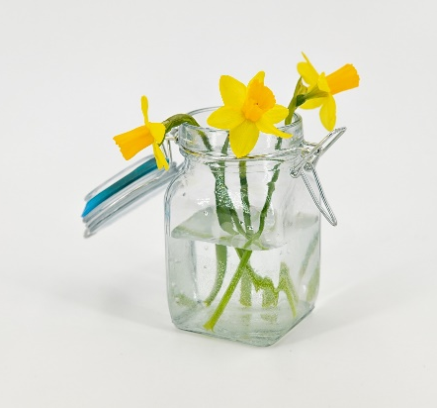
May the Lord bless you and keep you.
²⁵ May the Lord show you his kindness.
May he have mercy on you.
²⁶ May the Lord watch over you
and give you peace.” Numbers 6:24-26
Decorate an ordinary jar, tin, or box.
It may help to label it ‘Blessings Jar’, ‘Thankful Jar’ or ‘Gratitude Jar’.
Cut up slips of paper that can be folded to fit into the jar.

Keep your jar on your desk.
At the end of each day think of one thing that you can be thankful for that day it could be a small as no wet playtimes today!
Write the good thing on the paper.
Put the paper in your jar.

When you are feeling down or have had a bad day take one of the good things, the blessings, out of the jar and read it.

You could do this with your class as a group.

You need
- A jar such as a large jam jar. Or you could use a tin or a box.
- Sharpie pens or pens that will write on glass
- Stickers, or self-adhesive ribbon to decorate your jar
- Small strips of paper

