Nativity Paper Chains

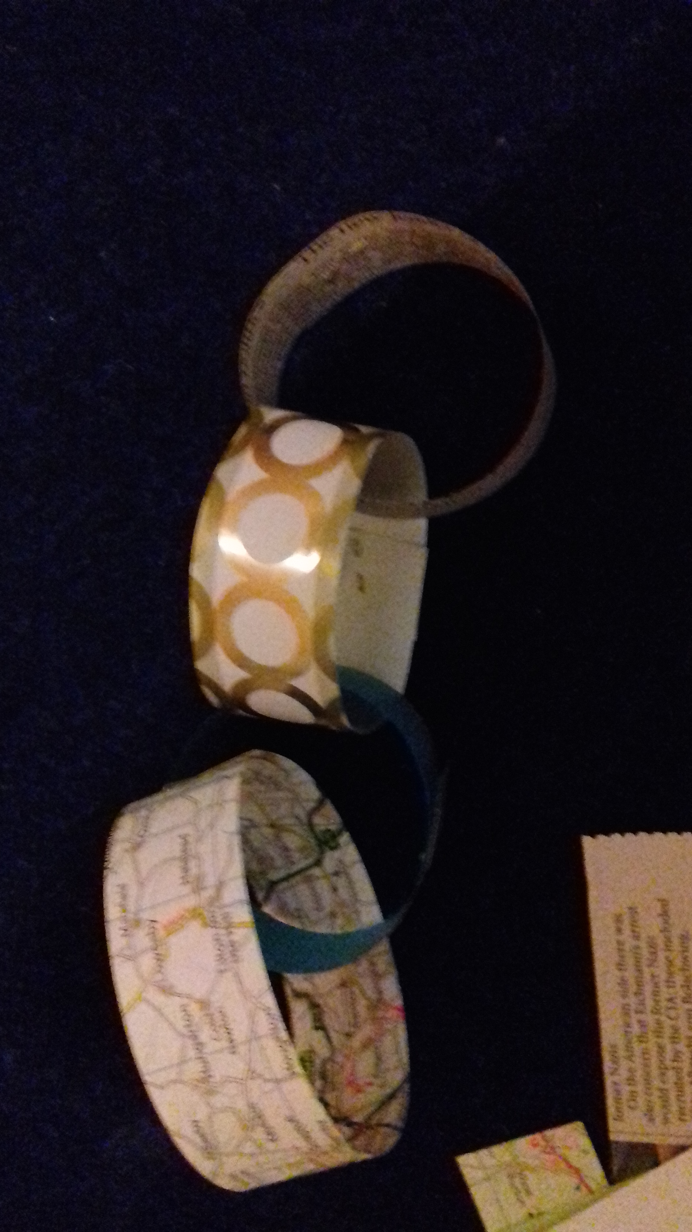
You will need
- Strips of a variety of different types of paper.
E.g wrapping paper for; new baby, Christmas, birthday
Wrapping paper that is; plain, patterned shiny etc
newspaper, brown paper, an old road atlas, puzzle book
- A simple version of the events of Christmas that includes the characters you wish to focus on.
- Staplers, or glue sticks

To make it simpler to set up you could just use different coloured photocopy paper.

Instructions
Put plenty of strips of different papers and staplers or glue sticks on the table for each group.
As you tell the story each time there is a new character stop and ask the children to select a paper strip that represents that character to them and add it to the paper chain. You may prefer to do this with events in the story such as a journey, finding nowhere to stay etc.

At the end ask the children to retell you the story explaining why they chose that paper for a few of the characters.

This could be done for other Bible stories and for more abstract ideas such as the Fruit of the Spirit or psalm 23.

