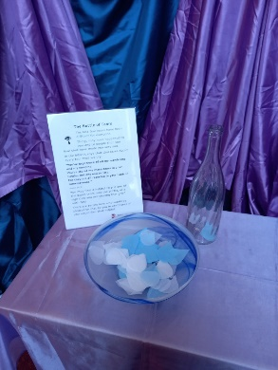
The Bottle of Tears
“You’ve kept track of all my wandering and my weeping.
You’ve stored my many tears in your bottle—not one will be lost.
For they are all recorded in your book of remembrance.”
Psalm 56 :8

The last few years have been difficult for everyone.
Things may have happened to you and to people that you love that have made you very sad.
In the Bible it says that God cares about every tear that we cry.
You may find it helpful to put one of the paper tears into the bottle, as a sign that you are sharing that grief with God.

You need
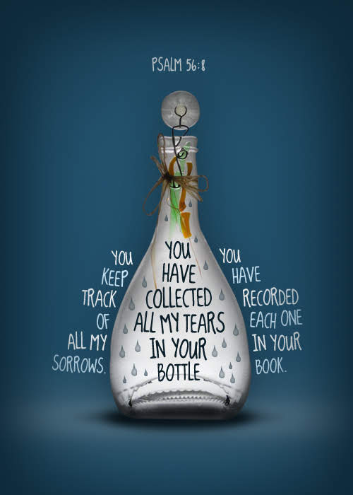
- An attractive bottle.
- Tear shapes cut out of tissue paper
- I have an additional glass bottle with battery fairy light inside to decorate the station.
- You could print copies of this card for people to take away. Original is here
Search for images of Psalm 56:8 to find

