Forgiveness
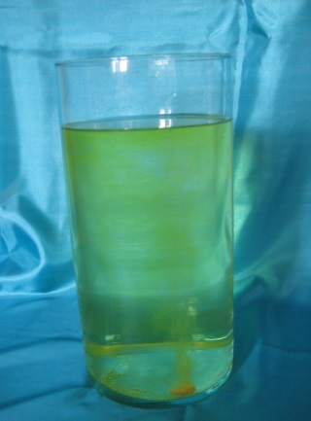
During the war many people were hurt by others, physically, mentally and emotionally. This activity offers pupils the opportunity to think about people who have hurt them, then to forgive them and let those feeling of hurt go.

Equipment:
- Large clear vases filled with water
- Soluble vitamin tablets broken in half. If you can source lemon or lime flavour you will need to change the water less frequently than with the orange ones!

Instructions:
This activity gives the pupils the opportunity to think about people who have hurt them. To forgive them and let that hurt go.
It is best to have team member near this activity to ensure that the pupils only put in one piece of tablet at a time and in case any pupils wish to share their hurts.

During the war lots of people were hurt. Some had physical injuries, others had seen terrible fighting that they found difficult to forget. It would have been difficult to forgive the person or people who had hurt them.

Sometimes people do and say things to hurt us on purpose.
Sometimes they don’t mean it, but it hurts anyway.
Has anyone hurt you?
It can be difficult when someone has hurt you. Forgiveness is hard, particularly if the hurt is repetitive behaviour or abuse.
If you want to, take a vitamin tablet and think about those hurt feelings. Then drop it in the water. As its fizzes away let those hurt feelings go, imagine forgiving the person and the hurt disappearing. Encourage the pupils to watch until the table has completely dissolved.
As the water changes colour, it’s a reminder that actions often have consequences and that the consequences may go on even after the person has been forgiven. Forgiveness itself may need to be an ongoing, conscious process.

You will need to change the water regularly because it becomes difficult to see the fizzing as the tablets dissolve.

Adults should be aware that pupils may want to talk about their hurt feelings. This activity could lead to some safeguarding issues being disclosed, and professional help sought. Forgiveness does not mean that the person perpetrating the hurt or abuse is given a mandate to continue. Adults need to be clear about the safeguarding procedure agreed with the school for the Prayer Space.

Forgiveness –
Forgiving others When They Hurt You.
We get hurt.
Sometimes people do and say things to hurt us on purpose.
Sometimes they don’t mean it, but it hurts anyway.
Has anyone hurt you?
It can be difficult when someone has hurt you. Forgiveness is hard.
If you want to, take a vitamin tablet and think about those hurt feelings. Then drop it in the water. As its fizzes away let those hurt feelings go; imagine forgiving the person and the hurt disappearing.

You may want to talk to an adult you trust about these hurts.

