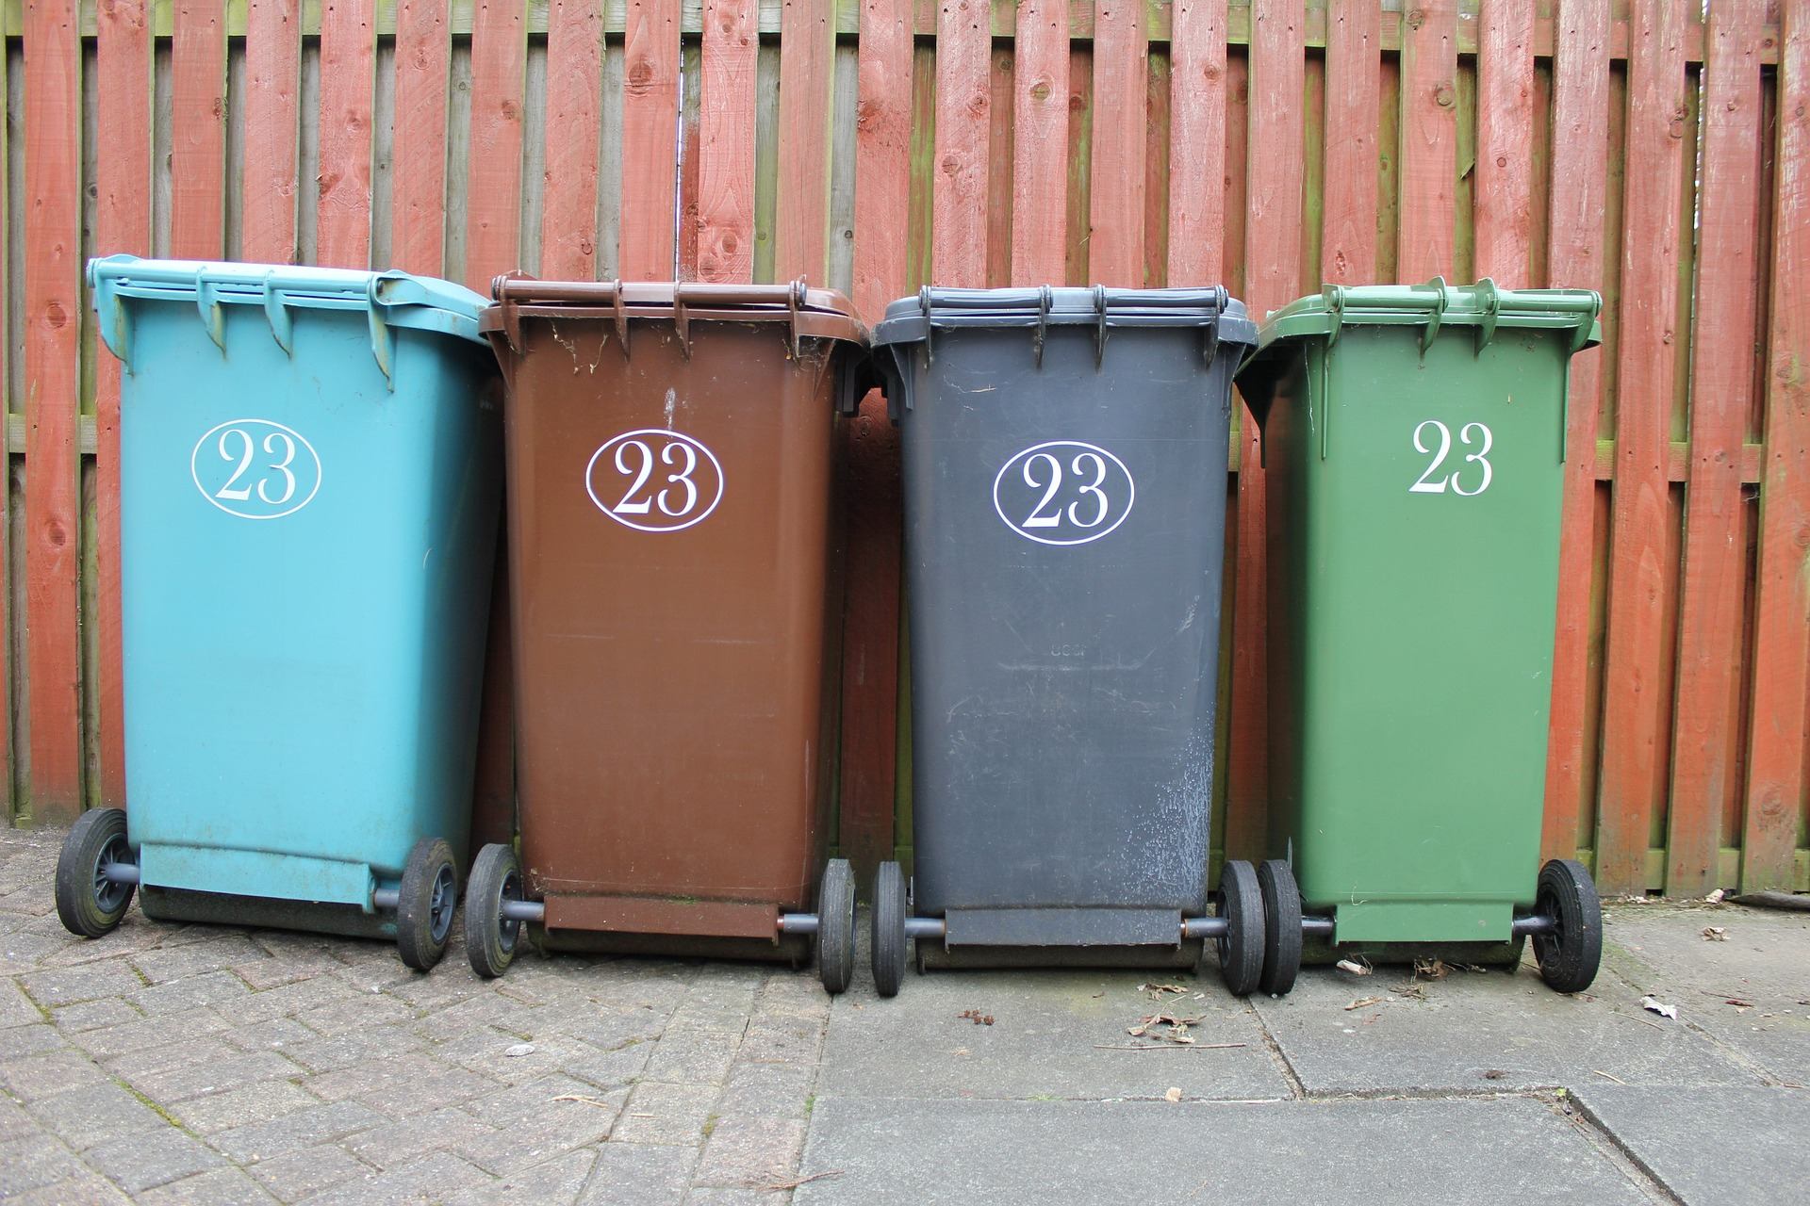
1. Twin your bin!
There is an accompanying PowerPoint for this assembly
Age range: Primary
Theme: This term, we begin with marking Earth Day – a worldwide environmental initiative, encouraging us all to be more eco-focused. This collective worship will explore the world of bins – and feature an opportunity to make a difference across the world, using your bins!
How does this link to your school’s Christian vision & values?
This week, we are featuring the opportunity to make a difference, with courageous advocacy at the heart of the reflection time. We will pick up the theme of Leaders in the next week’s collective worship, but focus here on how our actions can make a difference – we are modelling being good citizens of the world for the future.
Resources:
- The PowerPoint slides are numbered with a point in the script so you can find your way, and the parts in bold show you where to click on to activate the next slide or animation. There are slides to go with today’s script, but you could quite easily use this collective worship without the PowerPoint if you preferred.
- Find out more about Earth Day: Earth Day: The Official Site | EARTHDAY.ORG or Bin Twinning from TEAR Fund: GET INVOLVED WITH EARTH DAY 2023 - Bin Twinning and materials for schools: Schools - Bin Twinning There are also lots of tips to help reduce the amount of plastic waste we produce: Reducing UK Waste - Bin Twinning
- For the fun bit at the start, you will need some crumpled up paper from your recycling, that you have added statements onto (see p.4)
- Reflective activity: use the extra materials suggested in the schools Bin Twinning pack (above)
Gathering:
- This term, we are going to be finding out about – and following the example of – leaders from all over the world, and so our new greeting reflects this.
- Slide 1: Use these new gathering words for this term, or your usual greeting if you prefer. The greeting comes with BSL signing, you can view the demos using links under the slide.
Leader: As we share these stories of leaders…
ALL: May we follow their example in thoughts and words and actions.

Signs for greeting: click on links
Thoughts: British Sign Language BSL Video Dictionary - thought (signbsl.com)
Words (use 3rd definition): British Sign Language BSL Video Dictionary - word (signbsl.com)
Actions: British Sign Language BSL Video Dictionary - action (signbsl.com)
Engaging:
- Slide 2: What are these pictures about? [Talk together for a few moments]
- We know quite a lot about how our rubbish is affecting our oceans, our climate and our environment – and many of us try to take the part we have to play in this very seriously.
- Slide 3: Earth Day is this coming Saturday, and it will be celebrated in different ways across the globe. One Christian charity, TEAR Fund, is using the whole of this week to raise awareness of environmental issues in some of the poorest and most vulnerable communities across the world – in a very simple way. [You might want to get involved yourself as a school, but at least use the slides to explain the initiatives of Bin Twinning, shortly]
- Slide 4: Before we find out a bit more, we’re going to take part in a rubbish activity! Here at the front, you’ll see some rubbish – and we’ll find out some facts about how important it is to be aware of what happens to our rubbish, and the difference that we can make in our world. . [use your recycled rubbish facts]
- Slide 5: These slides come from TEAR Fund’s materials for schools: find the complete presentation here. Some words have been adapted for the ages of our pupils. The people who work for a charity called TEAR Fund are showing us how to be good leaders in looking after our world – and the people who share it with us.
Bin-Twinning-intro-presentation.pptx (live.com)
- Slide 6: Bin Twinning is a bit like Town Twinning, where two towns across the world are linked – but you link your bin…
- Slide 7: …with a rubbish collection and recycling project in one of the poorest places on the planet.
- Slide 8: 2 billion people in the world are living among mounds of rubbish, like this, because they don’t have their waste collected and safely disposed of.
- Slide 9: In communities that don’t have waste collection services, residents feel they have no choice but to dump or burn their rubbish. Waste either gets added to open dumps, thrown in waterways which lead out into the ocean, or it is burnt, creating toxic fumes and air pollution that are breathed in by local residents.
- Slide 10: This is Meera. The piles of rubbish in Meera’s community mean that there are lots of mosquitoes, which spread diseases. Recently, Meera was ill for months and medicines cost lots of money.
- Slide 11: All these people are twinning their bins! They donate money to TEAR Fund who give them a special sticker to show that their bin is twinned – and the money they have raised have done this….
- Slide 12: Bin Twinning has helped to set up businesses that collect rubbish, dispose of it safely, and recycle as much as possible. Many of these projects upcycle waste into items for sale – from compost to paving blocks – and proceeds are given back to the local community and provide local people, from poor communities, with work.
- Slide 13: So, if you were to twin your bin with Uganda, you’d be twinning with a recycling enterprise in Masaka that is setting up three paving block factories to recycle up to 30 tonnes of plastic each month. Many of the people who work there wouldn’t normally have the chance to work because they are women, or disabled. Bin Twinning makes a big difference!!
- Slide 14: With Bin Twinning, people are helping to…. Save lives – Protect the planet – Create jobs
- Slide 15: There are lots of ideas to help you to do things in school this week to raise funds to twin your bins – or to help you to be less wasteful with plastics. I wonder what we could achieve together?....
Slide 16: Responding (words for worship):
….in the stillness of this moment, let’s be quiet and think…..
In the Bible, Christians read about God’s plan for the beautiful world he had made – you might remember that many times he said ‘That’s GOOD!’!! When he made people, it was clear that it was the people’s job to look after the world. So today, we are going to use some words that reflect this in our thoughts and prayers.

Slide 17:….we’ve heard today lots of facts about plastic waste and its impact on our world….
….and how 2 billion people across our world live in an environment that none of us would like….
…. I wonder how you’d feel, living here?....
…. I wonder what you’d want to change?....
…. I wonder what we’ve learned today that might change our actions?....
….I wonder how our actions might show that we are caring for the world?....

[give some space for silent reflection here]
I’m going to turn my thoughts into a prayer now. If you’d like to pray too, then join in with the words ‘We will care for all you’ve made.’

Slides 18-22: Prayer
Slide 18: Creator God
You made our world beautiful, for us to share ….we will care for all you’ve made.
Slide 19: When we see something that’s wrong, ….we will care for all you’ve made.
Slide 20: With every piece of rubbish that we clear away….we will care for all you’ve made.
Slide 21: With every single thing that we recycle ….we will care for all you’ve made.
Slide 22: As your children on this earth, ….we will care for all you’ve made.
Slide 23: Amen
Sending: Slide 24
Leader: As we leave this place and time and go into the day ahead…
All: May our actions – and our bins! – make a difference.

To listen to / sing:
One World from Nick & Becky Drake
**Reflective activity:
Use one or more of the activities suggested in the Bin Twinning resources.
There is a reflective card to put in your classroom to help your children to keep thinking, reflecting and/or praying.

Print onto recycling paper and scrumple up to resemble rubbish

How many pieces of plastic does the average person throw away in a year?  1. 700  2. 4000  3. 6000 | If you piled up all the plastic that people in the UK throw away in a year, how many times would it fill Wembley Stadium?  a. 23 b. 10 c. 8 | How many plastic bottles are sold around the world every minute?  a. 1000  b. 10,000  c. 1,000,000
How long does it take the average plastic bag to break down?  a. 1000 years  b. 100 years  c. 10 years | What percentage of the world’s plastic is recycled?  a. 51%  b. 9%  c. 27% | Who can help reduce the amount of plastic in our world?  WE ALL CAN!!!

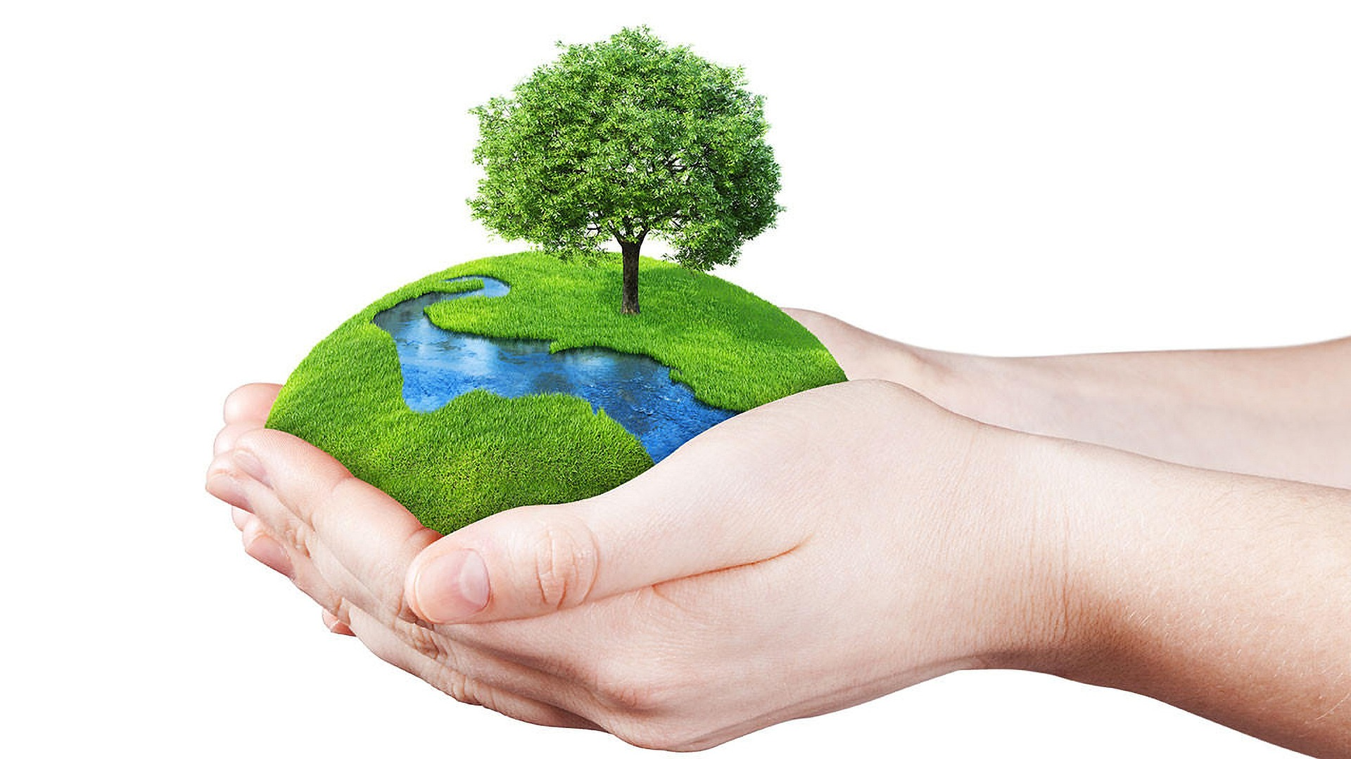

“God put Adam in the Garden of Eden to care for it and work it.” Genesis 2:15

Look at this picture and think about what it is saying to you.

What do you do at home and in school to care for the world?

What more could we do? Make a list of small things that might make a BIG difference – and DO THEM!!!

“….we will care for the world God made.”

