Celebrating Harvest in Primary Schools 2020
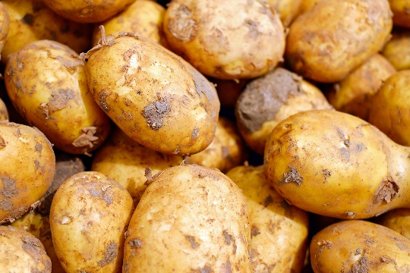
Below are some resources that may be of use for celebrating harvest festival in your school. These are mainly for primary schools including ideas for EYFS and nursery to use in the classroom.

Assemblies.org – www.assemblies.org.uk
The new harvest assemblies for this term are on the September current assemblies page.
https://www.assemblies.org.uk/pri/
If you put harvest into the search bar it suggests a lot of past assemblies
SPCK Assemblies - Find an Assembly

Barnabas In Schools - www.Barnabasinschools.org.uk
Harvest | Barnabas in Schools
Ideas for use in collective worship or RE lessons around the theme of creation and harvest in the Bible.

Bible Chat Mats
https://www.bathandwells.org.uk/supporting-children/youth-children/resources/bible-chat-mat/
Pages of pictures to go with Bible stories that pose questions and include the opportunity for reflective colouring. There is a harvest one.

BRF Ideas Hub
https://ideas.brf.org.uk/topics/harvest
The ideas on this site are for churches but might work for your harvest festival celebration with the school.

Cafod – www.cafod.org.uk
Primary teaching resources | CAFOD
Cafod is a Catholic charity that produce some useful resources.

Church of England #Faith at Home
During lockdown the Church of England produced collective worship materials that could be sent home or used in school. Scroll to the bottom of this page to find the 10 collective worships on values from last term. The generosity one may be useful for harvest.
This term they are producing a harvest resource it will be published 28th September
www.churchofengland.org/faith-action/faith-home/i-am-school-leader#na

Flame Creative Kids - Flamecreativekidsblogspot.com
Flame: Creative Children's Ministry: harvest
Ideas around creation and harvest mainly for use with younger children. Unusually includes lots for EYFS and nursery.

Christian Aid - www christianaid.org.uk
Primary school teaching resources | Christian Aid
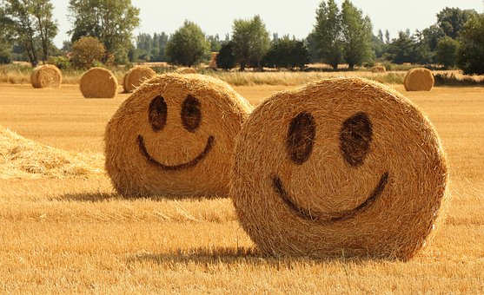
A mix of materials for Collective Worship here, all suitable for harvest. Scroll down to the bottom of the page for assemblies on food and fair trade.

Faith and Worship.com
https://www.faithandworship.com/Prayers_Autumn.htm#gsc.tab=0
This website includes prayers for all situations and season. Written for adults but there are some there you could use with children.
The prayer memes here could be useful. http://www.prayermemes.co.uk/

Free Bible Images – www.freebibleimages.org
If you use a Bible story as part of your harvest celebrations you are likely to find images to go with it on this website.

Pixabay – Free to use photographs- It may not opne from this link. Type Pixabay into your browser. Stunning Free Images · Pixabay
This website contains thousands of good quality photos that are free to use in presentations and lessons. No attribution required. Beware that the top line of the page are shutterstock and do require payment but below that very good. See examples in this bulletin.

The Salvation Army – www.salvationarmy.org.uk
https://www.salvationarmy.org.uk/resources/schools-resources/seasonal-assemblies-primary
A variety of harvest collective worships with powerpoints.
