Safeguarding Leadership Training

Course Resource Pack

Version: September 2023



We recognise that safeguarding training can be emotive and triggering. If you have any questions or concerns arising from as aspect of the training, please do not hesitate to contact one of the Guildford Diocese safeguarding team.
- Introduction
The National Safeguarding Learning and Development Framework sets out the vision for safeguarding learning to ensure that all Church officers develop skills and knowledge in safeguarding to an appropriate level.
As a Church we recognise the importance leaders play in creating and maintaining a safe environment for all, in whatever way they support the work of the Church. We are committed to enabling leaders to develop and maintain the necessary knowledge, attitudes, behaviours and skills to safeguard and protect children, young people and vulnerable adults.
This pathway supports our Church vision. It is essential that we understand safeguarding as a theological imperative, rooted in the nature and love of God, and outworking in basic commitments to giving equal worth to all.

The Church has committed to developing a set of National Safeguarding Standards as part of a quality assurance framework. The quality assurance framework currently under development will be a mechanism for:
Asking and answering the question: How well are we doing this and what is the difference / outcome being achieved?
Analysing the answers to this question to gain learning and deepen organisational safeguarding understanding and expertise.
Using that learned expertise to drive systematic change and continuous improvement in both the quality and impact of the activity, and to increase our knowledge and understanding of the evolving nature of Church-based abuse.
This training has been built around these National Safeguarding Standards
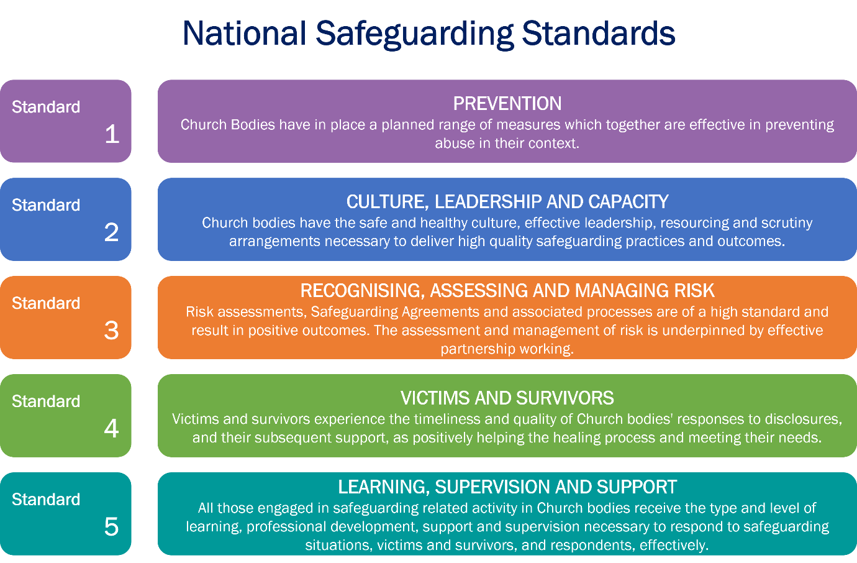

- Learning Outcomes
This pathway is intended to be transformational. Once people have completed it, the aim is that they are in some way different from the people they were at the start. The aim is that participants reflect deeply on their own values and beliefs and integrate these with the values and beliefs underpinning good safeguarding behaviour. The idea is that good safeguarding behaviour can then flow from an inner motivation, rather than be experienced as an external process to be followed under duress.
By the end of this pathway participants will:
• Understand how safeguarding concerns and abuse can be prevented within their context.
• Understand how healthy culture, and safe and effective leadership, shape Christian communities that are healthy, safe, and have the capacity to deliver high quality safeguarding practices.
• Recognise when risk assessment and management processes are required, understanding when, why and how they must be utilised.
• Understand more of the impact that abuse and trauma have on individuals’ lives, relationships, and interactions in a community setting, leading to better responses to victims and survivors.
• Evaluate their learning and translate this into an individual plan of action that will improve their safeguarding practice and responses.

- Structure of the training
This training aims to encourage a process of reflective learning involving individual tasks and groupwork. As such you need to prepare tasks for both group sessions and an evaluation task following the second session. You need to submit answers to the tasks before session 1 and following session 2.
Answers to the tasks are written in a Microsoft form. Links to the Microsoft forms to be used for Session 1 are found in this workbook, on the website and in email communications from the safeguarding team.
You have until 4 working days before session 1 to submit your answers. An email will be sent from the Safeguarding Trainer to clarify the final cut off point for your course.
Following session 2, you will send a link to another Microsoft form to submit your final evaluation task. You will not receive your certificate if you do not submit this form.
Please note that only Certificates for Clergy and Licensed Roles are recorded by the Diocese.

- Flowchart

- Session One Preparation
Session one focuses on National Standards one Prevention and two, Culture, leadership, and capacity. This session will draw on reflections from your preparation work and your own experiences of healthy cultures. The session places focus upon creating environments in which everyone is and feels safe and can flourish citing this as fundamental to our purpose as God’s Church.

Task 1 – no need to submit written work for this task
Consider these statements around the six aspects of the culture cube. Do you agree or disagree, perhaps you are not sure. Can you explain why? Take notes and be ready to share in the session.
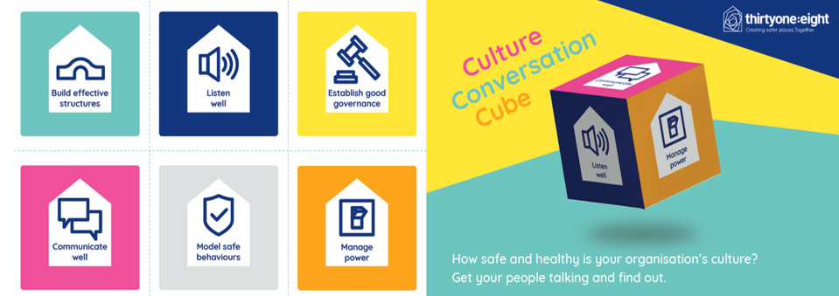
Establish Good Governance  Our procedures and the expectations on people are clear, consistent and easy to understand. | Listen Well  Our church has a culture that encourages us to be humble in the way we respond to issues and learn from them. | Build Effective Structures  The way our church’s structure works displays and develops safer, healthier culture.
Model Safe Behaviours  Our routines and rituals take into account how they might affect people who are vulnerable | Communicate Well  Our church clearly communicates what a safe place looks like so everybody understands what’s expected of them and others. | Manage Power  In our church I see people displaying safe and healthy attitudes, values and behaviours.
A full version of the Culture Conversation Cube handout can be found on the Safeguarding Leadership Training page of the Diocese of Guildford webpage. Additional materials for this exercise are suggested here: Code of Safer Working Practice & The Guidelines for Professional Conduct of the Clergy.

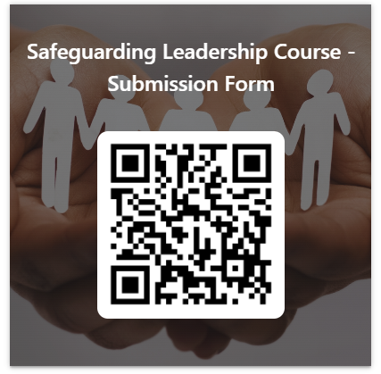
Task 2 – submit responses via Microsoft form Click here https://forms.office.com/e/64M5Fi69hy or scan QR Code

Question 1

Imagine being a member of a church with a healthy culture.
- What would you see?
- What would you hear?
- What would you feel & experience?

Question 2

What can you in your leadership role contribute to creating the healthy culture you’ve imagined in question 1?

Task 3 –no need to submit written work for this task
Download from our website a copy of “Social GGRRAAACCEESSSS and Safeguarding”. If you prefer you can watch a 32 minute video presentation available on the Safeguarding Training Portal.

- Session Two Preparation
Session 2 focuses on the National Standards three of Recognising, assessing and managing risk and four, of Victims and survivors. It draws upon the discussions from session one around healthy culture, leadership and capacity using a scenario that emphasises how safeguarding concerns can be prevented from escalating.

Task 1 - no need to submit written work
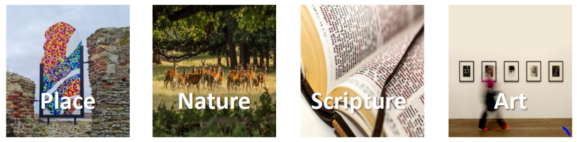
What has influenced your values and beliefs with regards to safeguarding?
Please identify a place, piece of art, scripture, or something from nature that reflects what has influenced your individual connection with safeguarding. We ask that you come prepared to this session being able to share what’s influenced you and explore how this has informed your responses, values, and beliefs regarding safeguarding.

Task 2 – no need to submit written work
Reflect on recognising, assessing, and managing risk.

Question 1

How confident are you in recognising and managing safeguarding risk on a scale of 1-10 (where 0 is not at all confident and 10 is extremely confident)?

Task 3 – read the scene setting for the case study
This will be sent via email following the first session.

- Evaluation Task response required, submit via Microsoft form
The history and experience of evaluation in “safeguarding training” – across all sectors, not just the Church - is that it tends to focus on the immediate self-reported capturing of people’s experience of the session itself. The limitation of this is that we just do not know if such training is having any impact – do people just “attend” the training event, tick that box, and carry on as before?
The evaluation that really matters is whether the “learning experience” has affected someone’s beliefs, values and understanding at a deep level so that there is a change in the person’s behaviours.
Complete the following tasks:
All participants to answer the following questions:
- What difference have I noticed in myself in my approach to safeguarding? (e.g. knowledge, attitude, learning, importance/integration with my work)
- What opportunity do I have or could use, to create a healthy church community?
- What would it look like for me to demonstrate behaviours that give equal value to all?
Additional task for clergy only:
- Develop a 4-6 month action plan with 3 to 4 objectives which will allow you to implement new and observable leadership behaviours which deliver concrete safeguarding outcomes and demonstrate that safeguarding is increasingly intuitive and at the heart of everything you do.
When developing this action plan consider how you would demonstrate the learning gained to:
Reflect on how safeguarding concerns and abuse can be prevented within their context.
Consider how healthy culture and safe and effective leadership shape Christian communities that are healthy, safe, and have the capacity to deliver high quality safeguarding practices.
Recognise when risk assessment and management processes are required, understanding when, why and how they must be utilised.
Understand more of the impact that abuse and trauma have on individuals’ lives, relationships, and interactions in a community setting, leading to better responses to victims and survivors.
Evaluate their learning and translate this into an individual plan of action that will improve their safeguarding practice and responses.

When creating your action plan think “SMART” – Specific, Measurable, Achievable, Relevant and Timebound
Objective  What would you like to implement? | Task/s  What do you need to do? | Success Criteria  What will it look like if you achieve your objective? | Timescale  When would you like to achieve this?

Your Certificate
You will receive your certificate up to 2 weeks after you have submitted your evaluation task.

- Further resources and support
The Church of England’s safeguarding policies and where to find them.
https://www.churchofengland.org/safeguarding/promoting-safer-church/policy-practice-guidance

Oakley & Humphries (2019) Escaping the Maze of Spiritual Abuse. Creating Healthy Christian Cultures. SPCK Publishing. https://spckpublishing.co.uk/escaping-the-maze-of-spiritual-abuse

Fife, Janet and Gilo (2019), Letters to a Broken Church. Ekklesia.
Harper and Wilson (2019) To Heal and Not to Hurt: A fresh approach to safeguarding in Church, Darton, Longman and Todd

Merchant (2020), Broken by Fear, Anchored in Hope: Faithfulness in an age of anxiety. SPCK Publishing. https://spckpublishing.co.uk/broken-by-fear-anchored-in-hope

Chevous, Jane (2004) From Silence to Sanctuary: A guide to understanding, preventing, and responding to abuse, SPCK Publishing. https://spckpublishing.co.uk/from-silence-to-sanctuary-pb

Southgate et al (2020) Tragedies and Christian Congregations: The Practical Theology of Trauma, Routledge. Tragedies and Christian Congregations: The Practical Theology of Trauma (routledge.com)

Cherry, Steven (2012) Healing Agony: Exploring the theology of forgiveness Bloomsbury: https://www.bloomsbury.com/uk/healing-agony-9781441156150/

The Independent Inquiry into Child Sexual Abuse, Report on The Anglican Church
The Anglican Church: Safeguarding in the Church of England and the Church in Wales (iicsa.org.uk)

The SCIE overview report
SCIE Final overview report of the independent diocesan safeguarding audits and additional work on improving responses to survivors of abuse.pdf (churchofengland.org)

Helplines for further support

Guildford Diocese
We recognise that safeguarding training can be emotive and triggering. If you have any questions or concerns arising from the training, please do not hesitate to contact one of the safeguarding team.

Safe Spaces
Safe Spaces is for anyone who feels they have experienced church related abuse of any form in England or Wales. Safe Spaces comprises a team of trained support advocates who have undergone specialist training in supporting survivors of sexual violence and who have received additional specific training in how the churches respond to abuse cases, the way in which faith and church-related settings have been used to carry out abuse, and the issues affecting people who have had or still have, a relationship with the church. You can contact the Safe Spaces team by:-
Tel: 0300 303 1056 (answerphone available outside of opening times)
Email: safespaces@victimsupport.org.uk
A live chat service is also available through the Safe Spaces website - Safe Spaces England and wales – Safe Spaces England and wales
The Safe Spaces team are available through their helpline and live chat service on:
Monday, Tuesday, Wednesday, Friday, Saturday: 10am-6pm and Thursday: 12pm-8pm

A “Church Officer” is anyone appointed/elected by or on behalf of the Church to a post or role, whether they are ordained or lay, paid or unpaid.
The exact wording of the Church’s safeguarding standards is still draft, awaiting approval by the National Safeguarding Steering Group in May 2023, but the five standard areas will be the same.

