God is right beside me
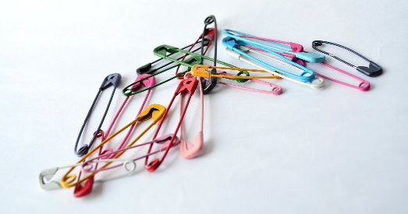
I know the Lord is always with me.
I will not be shaken, for He is right beside me.. Psalm 16:8
Last year was challenging; when we started back in September we never could have guessed how different our world would be by the end of the spring term.
None of us know what this year holds, but we do know that God is with us, right beside us, what ever happens.

We all face times that can be difficult and when we'd really like to know God is with us, or even times when we are on our own and feel lonely. God is always there, but sometimes it's hard to remember that when we can't see him!
Take a safety pin and pin it somewhere on your clothes as a reminder that God is always with you and keeps you safe. You might prefer to put it somewhere where no-one can see or you might have it on show as a potential talking point! You might even want to personalise the safety pin with a couple of beads or a small strip of ribbon!

You need
- Some small safety pins
- You could provide some beads or ribbon to decorate the safety pins if people wish.

