A Jesse Tree
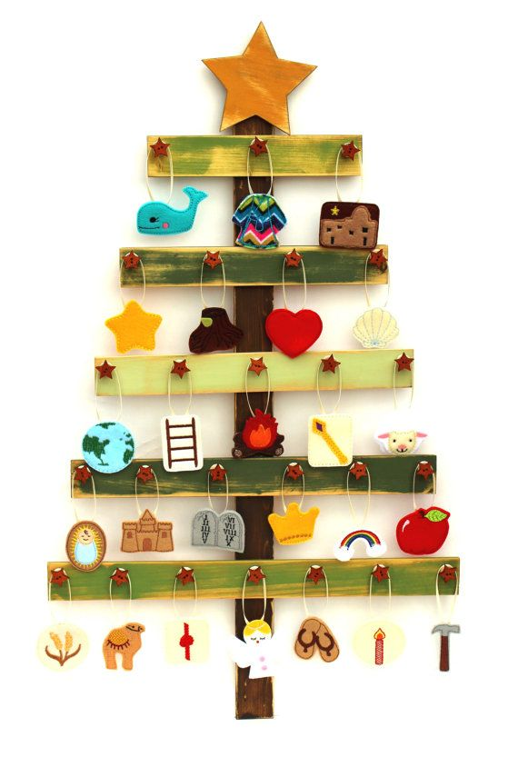
Jesse Trees are a very old Christmas Tradition that first started in medieval times. They are used to help tell the story of the Bible from creation to the Christmas Story. The name comes from Jesse who was the Father of the great Jewish King David and the prophecy in Isaiah that Jesus would come from ‘the root of Jesse’. ... Today Jesse Trees are used as a kind of Advent Calendar. You sometimes find Jesse trees in churches as stained glass windows carvings or paintings. Maybe your parish church has one?
The Jesse Tree is an idea that fits very well with our Big Bible Story, although it does of course, stop at Jesus birth. You can find out about which figures to put on the tree each day here www.whychristmas.com/customs/jessetrees.shtml This also gives you the Bible passages that go with each day. Could your worship team, make the ornament and lead this in your school each day? I have created a powerpoint version with images and Bible quotes. www.cofeguildford.org.uk/education/christian-distinctiveness/advent-and-christmas
There are Resources to help you to use a Jesse Tree in school on www.Eden.co.uk here www.eden.co.uk/shop/search.php?q=Jesse+Tree
A Jesse Tree for Advent by Rachel Nicolls is a new book this year. Her Lent book which was new last year was very creative.
A Jesse Tree for Advent provides 15 assemblies to take you through the school days of Advent, each based on a character from the Jesse Tree. There is also a Christmas assembly. Each outline includes:
a description of the symbol to hang on your tree
a story about the biblical character
a suggestion for further reflection
a prayer
There are ideas for creating a two or three-dimensional Jesse Tree, as well as five suggestions of projects or individuals for further study and links to other curriculum areas. An additional resource called Links to the Modern World emphasises that although the Jesse Tree stories come from the distant past, they are still relevant today.
Sourcing the ornaments
The pupils could make the ornaments for the tree or you can download templates and images to print or use in a slideshow for a very small cost on Etsy here https://www.etsy.com/search?q=jesse+tree+ornaments&explicit=1
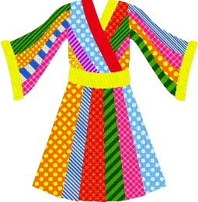
These are some of the clip art images bought from Etsy for £3.22!
