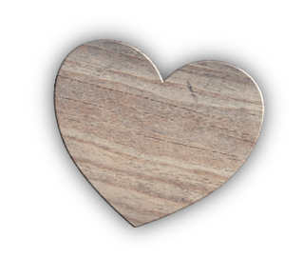
On My Heart
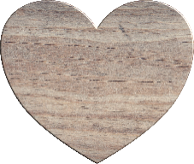
Give thanks to the God of heaven.
His love continues forever.. Psalm 136:26

We sometimes use the phrase that a person ‘is on my heart’. This is an opportunity to think about what is on your heart for next term.
Write your name on one heart.
On the other side write a few words to describe how you feel about the coming school year. Your hopes and dreams as well as concerns.

On the other heart write the name of your class, your school, or a group that you will work with this term.
On the other side write a few words to describe your concerns, hopes or prayer for them for the coming term.

Hold both hearts in your hands and pray for your pupils and for yourself and know that God loves you and God loves your pupils.
You could keep your hearts in your school bag to remind you of that God’s love when you rummage in your bag during this term.

You need
- Two small heart shapes You could cut these from paper or buy wooden hearts that are sold cheaply for wedding decoration.
- Pens

