
Collective Worship, Summer Term 2023: ’Follow my lead…’
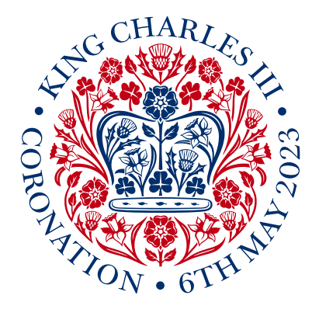
We gather as a community for collective worship that is inspiring, invitational and inclusive, reflecting the fact that we are a part of a diverse school family and the wider church community. This term, we begin with the story of King David, whose anointing forms the basis of the traditions and rituals that we will witness in the Coronation of King Charles III, an historic moment in the life of our nation. We look to David’s life for some inspiration about being a leader, and being human, but above all how God called him a ‘man after his own heart’. We will also look beyond his life to the lives of other leaders, from all walks of life and different parts of the world, marking some key dates in the religious calendar and thinking about what their lives teach us about being a leader. We also think about people in our own schools who are leaders, including our pupils – and what wise advice we might want to pass on.
w/b | Theme | Notes | Bible content | Song**
1 (17/4) | Earth Day: Twin your bin! | Let’s set a good example: lead the way in caring for the earth: Bin Twinning | Genesis 2:15 | One World (NBD)
2 (24/4) | Fantasy Feast | Thinking about people (leaders) who inspire us: who would you invite? Jesus tells a story about a Banquet…. and people who weren’t invited! | Luke 14: 15-24 | Together (NBD)
3 (2/5) | Chosen… | Samuel chooses a new king – what’s going to happen in the Coronation? | 1 Samuel 16:1-13 | Out of the Ark: To the sound of trumpets  Sing for the King  Nick & Becky Drake: Our King
4 (9/5) | What’s in your heart? | What did God see in King David’s heart? What sort of King will King Charles be? What’s ‘in his heart?’ What’s in our hearts? | 1 Samuel 16:7
5 (15/5) | On the throne | As King Charles continues his reign, we use the image of the throne to help us to reflect on / pray for people who are leaders….including ourselves | 1 Timothy 2:2
6 (22/5) | Filled up! | SUPER-Power! [the story of Pentecost] What ‘fills you up’? | Acts 2:1-13 | Golden Rule & Actions
HALF TERM
7 (5/6) | St Peter: ‘Feed my sheep’ | The story of the Early Church & Peter’s second chance | John 21; Acts 2:44-47 | Together (NBD)
8 (12/6) | St. Paul: What’s love got to do with it? | Paul, 1 Corinthians 13 & love being everything in leadership | I Corinthians 13:1-6 | Golden Rule (Actions)  Together as one or Let’s learn how to love (POP UK)
9 (19/6) | Born to run | The story of Wilma Rudolph, who was the 1st black woman to win 3 golds | Galations 3:28 | Never give up (POP UK)
10 (26/6) | ‘I have a dream’ | This summer marks 60 years since MLK’s speech ‘I have a dream…’ | Proverbs 31:9 | Never give up (POP UK)
11 (3/7) | Turning the Wheel | On Dharma Day, we find out about the leadership & example of the Buddha & show gratitude for our teachers | Galations 6:9 | While we live, we learn (AAOS)
12 (10/7) | Plant a tree! | The story of Wangari Maathai, environmentalist & first black African woman to be awarded Nobel Peace prize | Genesis 1:12 | One World (NBD)
13 (17/7) | Be a wise builder | We come full circle back to a well-known parable of Jesus, this time about building wisely. [Y2/Y6 Leavers: build a wall of wisdom] | Matthew 7:24-27 | Our farewell song (NBD)
Song references:
AAOS – All About Our School, BBC resources, links to online version; NBD – Nick & Becky Drake songs (we used these videos frequently during lockdown) ; POP UK are a new resource, free if you register

The School Musicals Company have written a set of songs for the Coronation, with a 100% discount code here: Coronation Songs for Schools | Coronation Assembly Songs (theschoolmusicalscompany.com) We have listed one ‘Sing for the King’
Nick and Becky Drake songs: Our King: Our King; Together: Together by Songs for School. A song to celebrate unity, community, and belonging. - YouTube One World One World by Songs For School; Golden Rule & Actions (for Golden Rule); Our Farewell Song: Our Farewell Song - by Songs for School. Leavers Song, Graduation Song. Year 6. Year 2. #leavers - YouTube
Never give up (POP UK); Together as one (POP UK); Let’s learn how to love (POP UK)

Linked research docs:
Wilma Rudolph resources: Garden of Praise: Wilma Rudolph Biography [There are also more links to explore on this webpage]
Martin Luther King resources: Who was Dr. Martin Luther King Jr.? - BBC Bitesize and Kid President’s version!: The Story of Martin Luther King Jr. by Kid President - YouTube
Wangari Maathai: Wangari Maathai | The story | About Wangari Maathai | Wangari Maathai Foundation

