**Teacher script: Please**

*Sit the children in front of the teacher with their hands open loosely on their laps. It’s important to allow some good pauses between sections, so that pupils are given plenty of time to think, reflect or pray.*

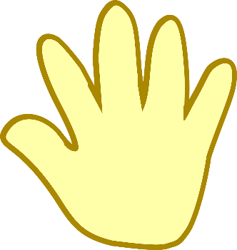

We use our hands for a lot of things! Without saying a word, our hands can show fear, or love, or anger, or comfort. We have used them to work, and eat, and help and play. Today we are going to use them to help us to express any worries or concerns that we might have, or things we might want to ask God to help us with. We are going to use the index finger of one hand to trace around each finger in turn as we think or pray *[teacher to demonstrate this]*

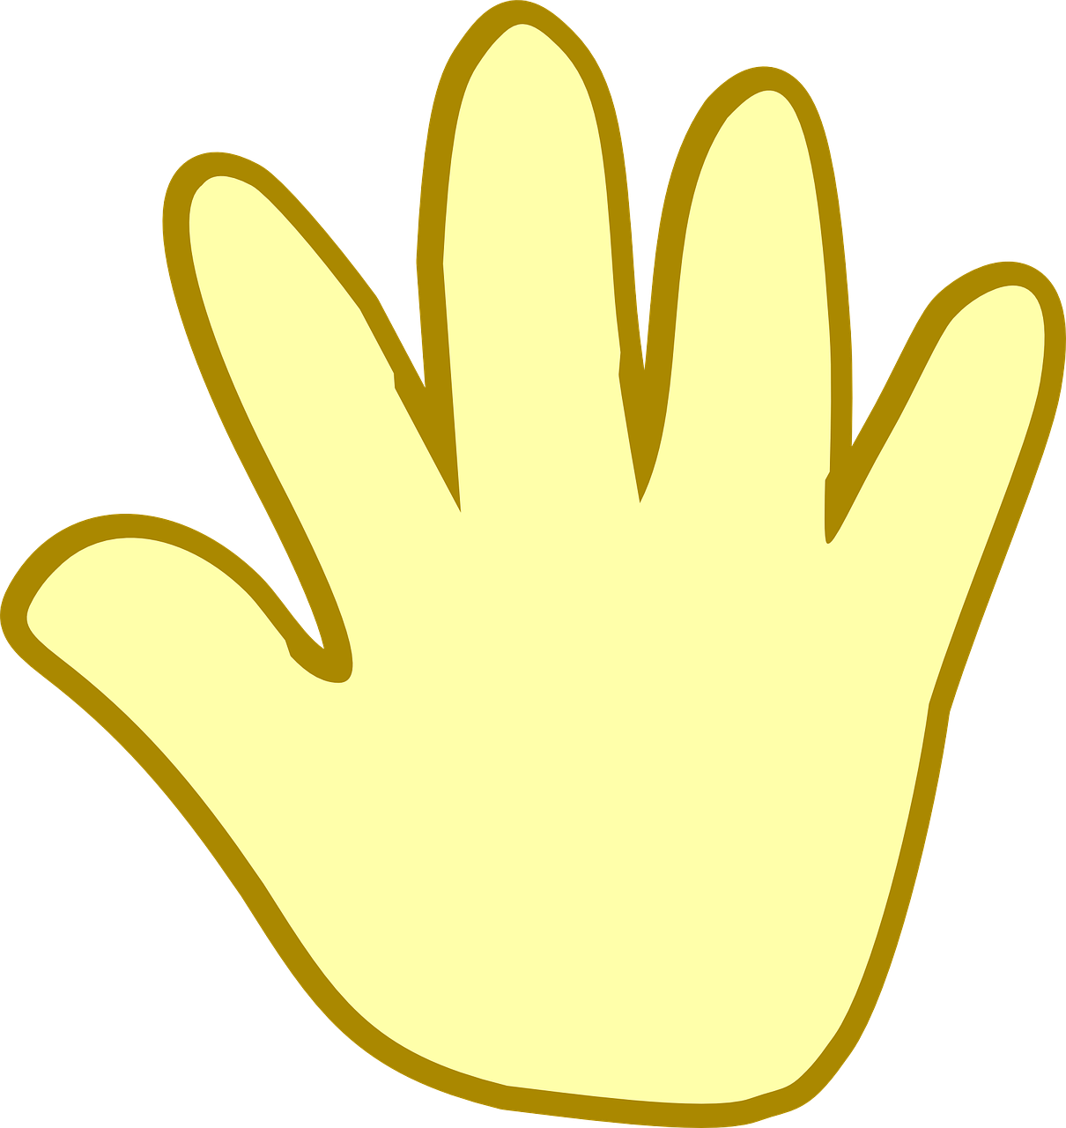

Before we begin, open your hands in front of you and rest them quietly in your lap. Let them relax as you breathe in and out……You might want to close your eyes.



* As you trace around your hand for the **1st time**, think or pray about **the school you are leaving behind.**
* As you trace around your hand for the **2nd time**, think or pray about **something you might be worried about.**
* As you trace around your hand for the **3rd time**, think or pray about **someone you care about.**
* As you trace around your hand for the **final time**, think or pray about **something you are excited about**.

As we end this time, open your hands in your lap again. You might want to imagine letting go of any worries or concerns and taking hold of the good things that you hope for.