Following your Conscience

This activity offers pupils the opportunity to think about and pray for people who standing up for what they believe is right.
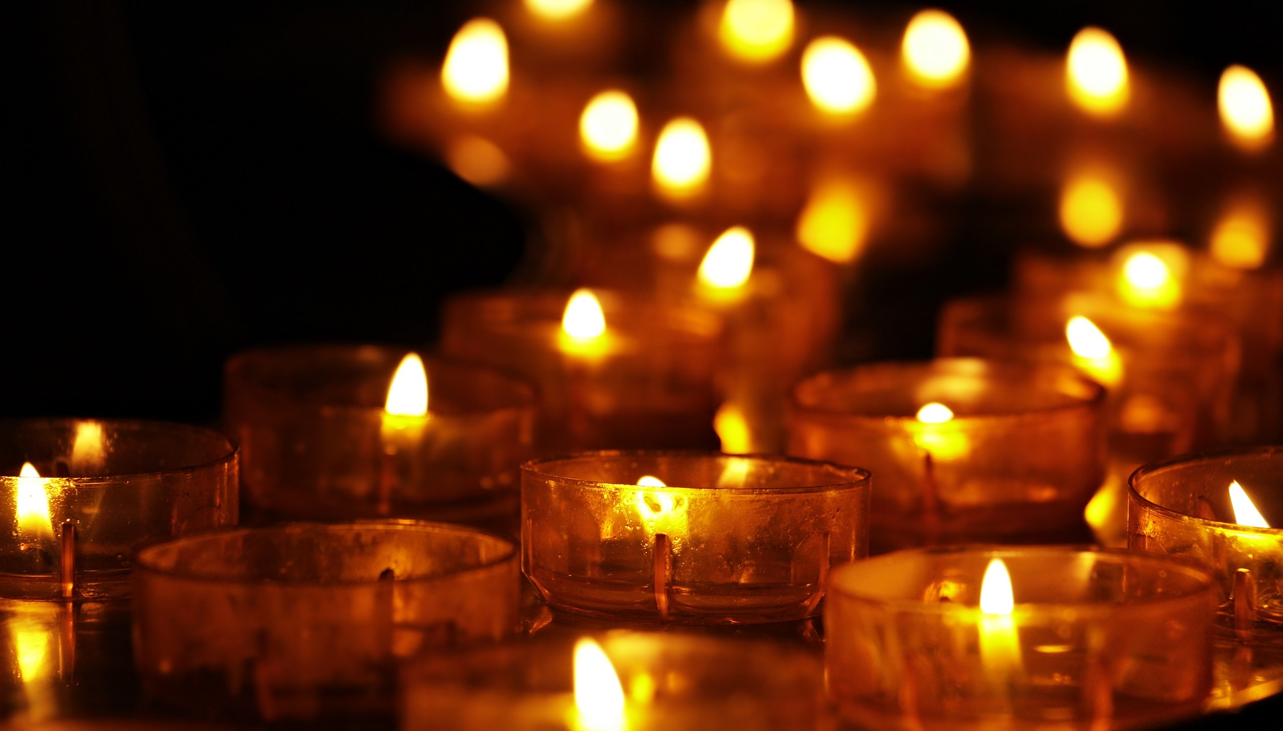
There is the opportunity to think about some of the conscientious objectors during the war and the impact of their decisions.

Equipment:
- Tea lights and tapers, or electric tea lights
- Some information about people standing up for what they believe is right that are in the current news.
- Information about conscientious objectors. see www.whitefeatherdiaries.org.uk for materials
- Information about those who are persecuted for their Christian faith see. www.opendoorsuk.org/ https://releaseinternational.org/idop/ and for materials.

Instructions:
When World War 1 broke out some people felt strongly that fighting wars was wrong. They refused to join the army. These people are called conscientious objectors. Many people thought that they were cowards, who were afraid to fight.
Some went to the front and worked as stretcher bearers, nurses, medical orderlies or cooks.
Some refused to do anything that would support the fighting and were put in prison.

You can read about some of them here. www.whitefeatherdiaries.org.uk

Today there are many people across the world who are standing up for what they believe is right, you can read about some of them here. https://www.amnesty.org.uk/
Read about those who are persecuted for their Christian faith here. www.opendoorsuk.org/ and
https://releaseinternational.org/idop/

Now light a tea light as you pray for them, in that situation.

Following your Conscience

Across the world there are people who are standing up for what they believe is right.
Light a tea light as you pray for them.

