# My Contribution to Peace

This activity offers the pupils the opportunity to think about their contribution to making and maintaining a peaceful society, both now and in the future.

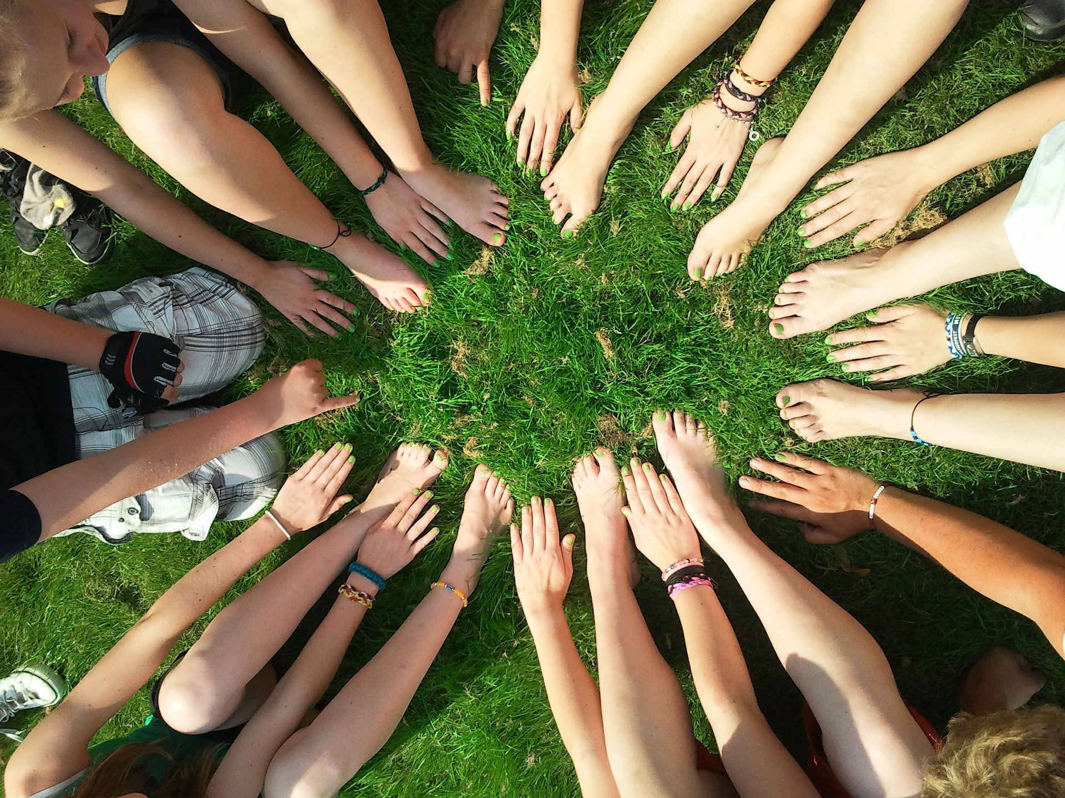Equipment:

* Paper of various colours cut into A5 pieces
* Felt pens
* Scissors
* Large piece or roll of paper*. This could be used as a banner or altar frontal*
* Glue sticks
* Labels with some ideas of what they could do to bring peace. Primary and secondary suggestions are attached.

Instructions:

This activity offers the pupils the opportunity to think about their contribution to making and maintaining a peaceful society, both now and in the future.

Encourage the pupils to think about what makes a peaceful society. Think about what brings peace to:

1. their class,
2. their family,
3. their community,
4. the world,
5. finally what they hope to do to bring peace in the future, when they are grown up.

Draw around their hand. Then on each finger write what they could do to bring peace, use one finger for each of these communities.

Cut out their hand shape and stick it onto the big paper.

**My Contribution to Peace**

Draw around your hand. Then on each finger write what you could do to bring peace to;

Your class – on your little finger

Your family – on the ring finger

Your street, or village or town – on your middle finger

The world – on your pointing finger

What do you hope to do to bring peace when you are grown up – on your thumb.

Cut out your hand shape and stick it onto the big paper with all the others.

Primary suggestions

|  |  |
| --- | --- |
| Chat with someone outside your usual friendship group today. | Surprise someone today. In a nice way. |
| Say something nice about someone behind their back. | Let someone into the line in front of you. |
| Say thank you to one of the adults in school today.  Remember to include the people who don’t work in a classroom. | Offer to help an adult at home or at school today. |
| Pray for peace in one of the countries where there is fighting. | Compliment someone on their work today |

Secondary suggestions

|  |  |
| --- | --- |
| Talk to someone outside your friendship group today. | Say something nice about someone behind their back. |
| Make contact with an adult in your family who you don’t see very often. Send a message or photo. | Find out about the life of someone your age in a country where there is war. Imagine what it would be like to swap. |
| Reply warmly to a post on social media from someone you haven’t replied to for a while. | Look at a news website. Read a story about a situation of war or conflict. Pray for peace in that place. |
| Post positive messages on social media. | Find out about one of the organisations that work to bring justice to the poor. |