Those Who Have Become Refugees

This activity offers pupils the opportunity to think about and pray for people who have had to leave their homes because of war and are now living in tent cities.
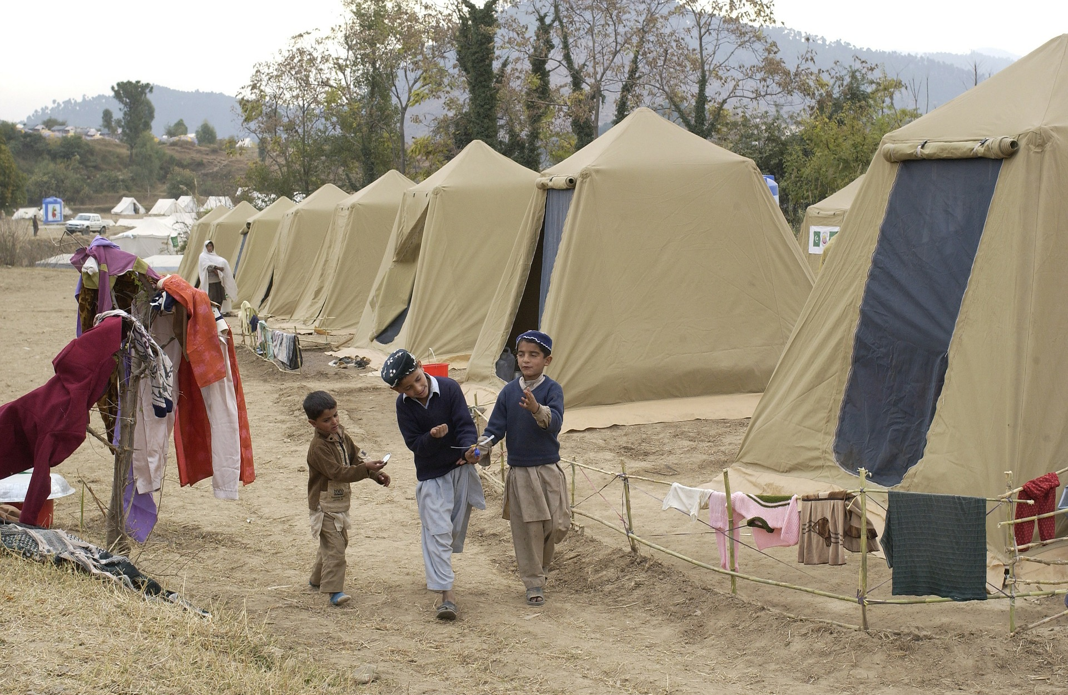
Equipment:
- Pieces of white card cut into A6 rectangles.
- A large flat service on which to build you tent city.
- Pens or pencils.
- Pictures of a tent city.

Instructions:
When there is fighting people often have to leave their homes. They do not have anywhere to go and so may have to live in a refugee camp in another country. Sometimes they live in tents in huge tent cities.
Can you imagine living in a tent all the time, even when it snows?

Take one of the pieces of card and fold it in half to make a simple tent. Inside write your prayer for the people who have fled their homes and are now refugees on the tent.

Place the tent with the others to make a model of a tent city as you pray your prayer.

Adults should be aware that there may be pupils who are refugees in the class, this activity needs to be approached sensitively if there are pupils who have had experience of being a refugee or asylum seeker.

Pray for Refugees

Many people who have to leave their homes because of war end up, living in tents in huge tent cities.

Take one of the tents and write your prayer for the people who have fled their homes and are now refugees on the tent.

Place the tent in the tent city as you pray your prayer.

